8.10: a) 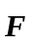 t=(1.04 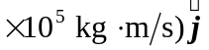. b) (1.04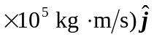.
c)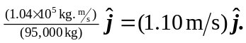 d) The initial velocity of the shuttle is not known; the change in the square of the speed is not the square of the change of the speed.

